Lab 3：MATLAB Programming

Authors | Name：何衍宁 Student ID:12311512  Name：夏天 Student ID:12311610
Objective
Lab3
In Lab 3, we primarily focus on building our proficiency with MATLAB to analyze and synthesize periodic signals using discrete-time Fourier series (DTFS) and fast Fourier transform (FFT). By utilizing the fft and freqz functions, we gain insights into the computational processes for calculating frequency responses of linear time-invariant (LTI) systems. Additionally, the tutorial guides us through simulating system responses using lsim, exploring the eigenfunction properties of complex exponentials, and evaluating the effects of simple filters on signals. These skills not only enhance our understanding of signal processing concepts but also equip us with practical experience in employing MATLAB for real-world applications..

Lab results & Analysis
3.8
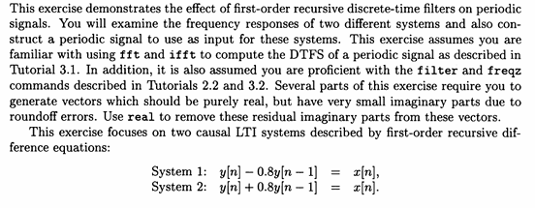
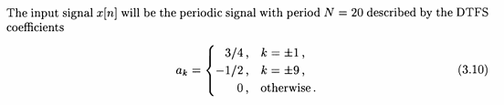

3.8 a
Intermediate Problems
(a). Define vectors a1 and bl for the difference equation describing System 1 in the format specified by filter and freqz. Similarly, define a2 and b2 to describe System 2.
Define a1,b1 to be the coefficients of the filter and freqz functions of system 1,a2, b2 to be the coefficients of the filter and freqz functions of system 2, representing a1,a2,b1,b2
Analysis:
Let's write it in terms of the definition of b and a.
clc;
clear;
a1 = [1,-0.8]
b1 = [1]
a2 = [1,0.8]
b2 = [1]

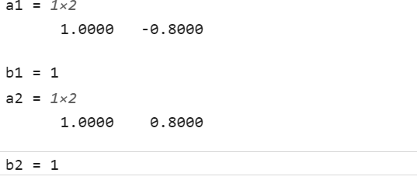

Lab result:
a1=[1 -0.8]; b1=[1 0]; a2=[1 0.8]; b2=[1 0];

3.8 b
The freqz function is used to find the frequency response of system 1 and system 2
(b). Use freqz to evaluate the frequency responses of Systems 1 and 2 at 1024 points between 0 and 2pi. Note that you will have to use the 'whole' option with freqz to do this. Use plot and abs to generate appropriately labeled graphs of the magnitude of the frequency response for both systems. Based on the frequency response plots, specify whether each system is a highpass, lowpass, or bandpass filter.
Analysis:
With the freqz method, the frequency is high near odd pi and low near even pi
clear;
clc;

a1 = [1,-0.8]
b1 = [1]
a2 = [1,0.8]
b2 = [1]
figure
a = linspace(2,2*pi,1024)
[H1,a] = freqz(b1,a1,1024,'whole')
[H2,a] = freqz(b2,a2,1024,'whole')
subplot(2,1,1),plot(a,abs(H1))
legend('H1(W)')
subplot(2,1,2),plot(a,abs(H2))
legend('H2(W)')
a1 = 1×2
1.0000 -0.8000
b1 = 1
a2 = 1×2
1.0000 0.8000
b2 = 1
a = 1×1024
2.0000 2.0042 2.0084 2.0126 2.0167 2.0209 2.0251 2.0293 2.0335 2.0377 2.0419 2.0461 2.0502 2.0544 2.0586 2.0628 2.0670 2.0712 2.0754 2.0796 2.0837 2.0879 2.0921 2.0963 2.1005 2.1047 2.1089 2.1130 2.1172 2.1214 2.1256 2.1298 2.1340 2.1382 2.1424 2.1465 2.1507 2.1549 2.1591 2.1633 2.1675 2.1717 2.1758 2.1800 2.1842 2.1884 2.1926 2.1968 2.2010 2.2052
H1 = 1024×1 complex
5.0000 + 0.0000i
4.9966 - 0.1226i
4.9865 - 0.2447i
4.9697 - 0.3657i
4.9464 - 0.4850i
4.9169 - 0.6022i
4.8812 - 0.7167i
4.8399 - 0.8282i
4.7931 - 0.9362i
4.7414 - 1.0405i
a = 1024×1
0
0.0061
0.0123
0.0184
0.0245
0.0307
0.0368
0.0430
0.0491
0.0552
H2 = 1024×1 complex
0.5556 + 0.0000i
0.5556 + 0.0015i
0.5556 + 0.0030i
0.5556 + 0.0045i
0.5556 + 0.0061i
0.5556 + 0.0076i
0.5556 + 0.0091i
0.5556 + 0.0106i
0.5556 + 0.0121i
0.5556 + 0.0136i
a = 1024×1
0
0.0061
0.0123
0.0184
0.0245
0.0307
0.0368
0.0430
0.0491
0.0552
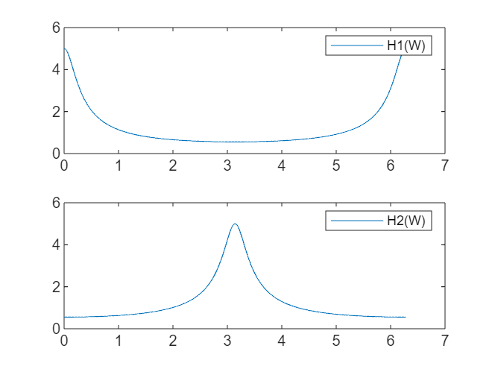

Lab result:
As can be seen from the figure, system 1 is low-pass filtering, and system 2 is high-pass filtering

3.8 c
(c). Use Eq. (3.10) to define the vector ax to be the DTFS coefficients of x[n] for 0=<k<=19. Generate a plot of the DTFS coefficients using stem where the x-axis is labeled with frequency wk = (2pi/20)k. Compare this plot with the frequency responses you generated in Part (b), and for each system state which frequency components will be amplified and which will be attenuated when x[n] is the input to the system.
Analysis:
Define a_x as a Fourier series for x[n], draw a picture of a_x at wk=(2π/20)k, and determine which part of the frequency is compared to the picture of problem b is enlarged, which part is reduced.
clear;
clc;
figure
ak = [0 0.75 zeros(1,7) -0.5 0 -0.5 zeros(1,7) 0.75];
wk = 0:pi/10:(pi/10*19);
stem(wk,ak,'filled')
legend('ak')

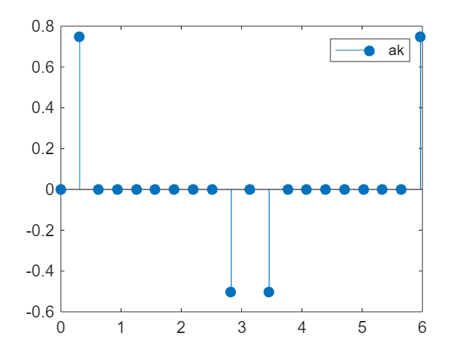

Lab result:
For high-pass systems, the frequency is amplified when k is odd and decreases when it is even. For low-pass systems, the frequency is amplified when k is even and decreases when it is odd. When x[n] is used as the input signal, ω1 and ω19 will be amplified, ω9 and ω11 will be weakened, and ω1 and ω19 will be weakened, and ω9 and ω11 will be amplified for system 2.
3.8 d
(d). Define x-20 to be one period of x[n] for 0=<n<=19 using ifft with a_x as specified in Tutorial 3.1. Use x-20 to create x, consisting of 6 periods of x[n] for -20=<n=< 99. Also define n to be this range of sample indices, and generate a plot of x[n] on this interval using stem.
Define x_20 as the set of vectors x[n] in the range 0 to 19, find the set x of vectors x[n] in the range -20 to 99, and plot x[n].
Analysis:
I use the ifft function to find x_20.
clear;
clc;
figure
ak = [0 0.75 zeros(1,7) -0.5 0 -0.5 zeros(1,7) 0.75];
wk = 0:pi/10:(pi/10*19);
x_20 = (20).*ifft(ak)
xn = [x_20 x_20 x_20 x_20 x_20 x_20];
subplot(2,1,1);
stem(0:19,x_20,'k','filled');
legend('x20[n]')
subplot(2,1,2);
stem(-20:99,xn,'r','filled');
legend('x[n]')
x_20 = 1×20
0.5000 2.3776 0.4045 1.4695 0.1545 -0.0000 -0.1545 -1.4695 -0.4045 -2.3776 -0.5000 -2.3776 -0.4045 -1.4695 -0.1545 0.0000 0.1545 1.4695 0.4045 2.3776

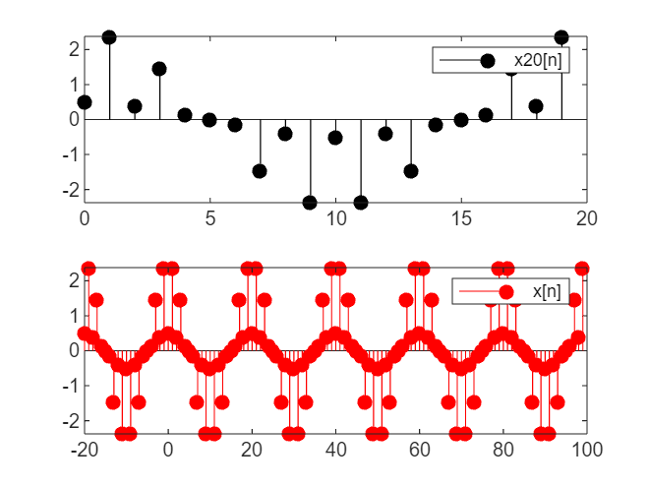

Lab result:
Figure is drawn.

3.8 e
(e). Use filter to compute y1 and y2, the outputs of Systems 1 and 2 when x[n] is the input. Plot both outputs for 0 =< n =< 99 using stem. Based on these plots, state which output contains more high frequency energy and which has more low frequency energy. Do the plots confirm your answers in Part (c)?
Calculate the output y1 and y2 of system 1,2, using the filter function, and draw a picture stating which contains more high-frequency energy
Analysis:
Draw the images. Whichever is denser is more frequent.
ak = [0 0.75 zeros(1,7) -0.5 0 -0.5 zeros(1,7) 0.75];
wk = 0:pi/10:(pi/10*19);
a1 = [1,-0.8];
b1 = [1];
a2 = [1,0.8];
b2 = [1];
x_20 = (20).*ifft(ak);
xn = [x_20 x_20 x_20 x_20 x_20 x_20];
n=0:99;
x=[x_20 x_20 x_20 x_20 x_20];
y1=filter(b1,a1,x);
y2=filter(b2,a2,x);
figure
subplot(2,1,1);
stem(0:99,y1,'k','filled');
xlabel('n');
ylabel('y1[n]');
legend('y1')
subplot(2,1,2);
stem(0:99,y2,'r','filled');
xlabel('n');
ylabel('y2[n]');
legend('y2')
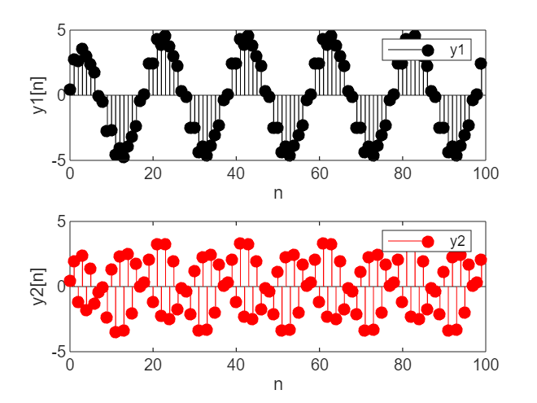

Lab result:
y2 has a higher frequency and more high frequency energy

3.8 f
(f). Define y1-20 and y220 to be the segments of y1 and y2 corresponding to y1[n] and y2[n] for 0 < n < 19. Use these vectors and fft to compute a-y1 and a-y2, the DTFS coefficients of y1 and y2. Use stem and abs to generate plots of the magnitudes of the DTFS coefficients for both sequences. Do these plots agree with your answers in Part (e)?
The fft function is used to compute the Fourier series of y1 and y2 in the range 0-19 and draw a graph
Analysis:
Use fft.
clc;
clear;
ak = [0 0.75 zeros(1,7) -0.5 0 -0.5 zeros(1,7) 0.75];
wk = 0:pi/10:(pi/10*19);
a1 = [1,-0.8];
b1 = [1];
a2 = [1,0.8];
b2 = [1];
x_20 = (20).*ifft(ak);
xn = [x_20 x_20 x_20 x_20 x_20 x_20];
n=0:99;
x=[x_20 x_20 x_20 x_20 x_20];
y1=filter(b1,a1,x);
y2=filter(b2,a2,x);
ky=0:pi/10:(pi/10*19);
y1_20=y1(1:20);
y2_20=y2(1:20);
a_y1=1/20.*fft(y1_20);
a_y2=1/20.*fft(y2_20);
figure;
subplot(2,1,1);
stem(ky,abs(a_y1),'k','filled');
xlabel('ωk');
ylabel('a_y1');
legend('a_y1');
title('figure1');
subplot(2,1,2);
stem(ky,abs(a_y2),'r','filled');
xlabel('ωk');
ylabel('a_y2');
legend('a_y2');

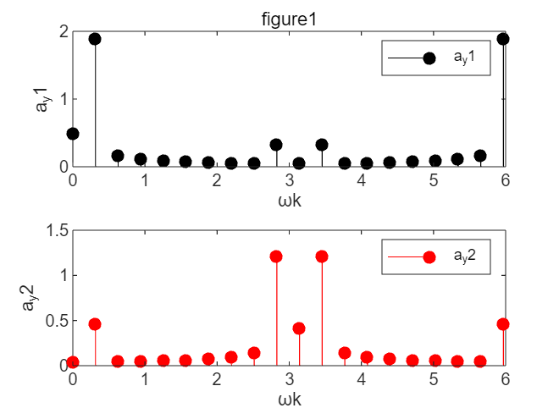

Lab result:
The discrete time Fourier series coefficients of y1 and y2 are drawn as shown above. According to the drawn images, the conclusion is consistent with that in question (e), y1 contains more low frequency energy and y2 contains more high frequency energy.

3.10 a
Advanced Problems
(a). Argue that computing each coefficient ak requires N + 1 complex multiplications and N - 1 complex additions. Assume that the functions e^{-jk(2pi/N)n} do not require any computation. Using this result, how many operations are required to compute the DTFS for a signal with fundamental period N? Note that the number of operations required is independent of the particular signal x[n].
While the DTFS is useful for analyzing many signals and systems, its popularity is due in part to the existence of a fast algorithm known as the Fast Fourier Transform (FFT). Before the landmark paper by Cooley and Tukey was published in 1965, the fastest algorithms used at the time for computing the DTFS coefficients required U(N²) operations. (O(N²) operations means that the number of complex additions and multiplications required is a polynomial in N of order 2. When characterizing the growth in computational complexity of an algorithm, the lower order terms can be ignored, since they become negligible for large N.) The FFT algorithm proposed by Cooley and Tukey, however, requires only O1.
(Nlog N) operations. For large N, the computational savings can be tremendous; e.g., for N = 800, compare N² = 1 x 10⁶ with NlogN = 3 x 10³. The difference is three orders of magnitude. The FFT essentially allows Fourier analysis to be applied to signals with very large fundamental periods. In the following problem, you will plot the number of operations required by the FFT and compare them with an U(N²) algorithm.
For the next two parts, you should assume x[n] has fundamental period N and takes on the values x[n] = (0.9)^{n} on the interval 0 =< n =<N - 1.

They want to figure out the total number of calculations in the process of finding the DTFS

Analysis:
According to the Fourier series calculation formula, to calculate each ak, we need to multiply x[N] by e^(-jwkn) a total of N times, and divide by N, a total of N+1 multiplications.
All N calculations are then added together for a total of n-1 operations, requiring a total of 2N calculations. There are N aks to calculate. So the total is 2*N*N=2N^2

This question needs no code.

Lab result:
The total value of DTFS is 2*N^2.

3.10 b
The problem requires to calculate the computation amount of FS calculated by the custom algorithm DTFS when x[n] = (0.9)^(n),N=8,32,64,128,256, and write the result into the dtfscomps array.
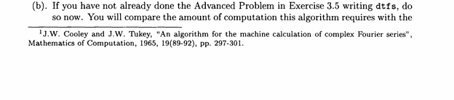

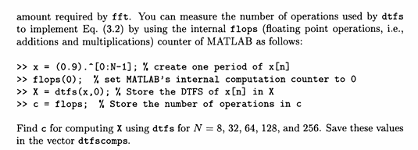
Analysis:
The flops function algorithm is inefficient and negligent, here the timeit method is used, x[n] is written and calculated. To improve accuracy, each N value is calculated 50 times and averaged in milliseconds. Then, log2(N) is the horizontal coordinate and t is the vertical coordinate.

clc;
clear;
figure
N0=[8,32,64,128,256];
dtfscomps=zeros(1,5);
function [X, x_reconstructed] = dtfs(x, synthesis_flag)
N = length(x);
X = zeros(1, N);
for k = 0:N-1
for n = 0:N-1
X(k+1) = X(k+1) + x(n+1) * exp(-1j * 2 * pi * k * n / N);
end
end
if synthesis_flag
x_reconstructed = zeros(1, N);
for n = 0:N-1
for k = 0:N-1
x_reconstructed(n+1) = x_reconstructed(n+1) + (X(k+1) / N) * exp(1j * 2 * pi * k * n / N);
end
end
else
x_reconstructed = [];
end
end

for i = 1:length(N0)
N=N0(i);
x = 0.9.^(0:N-1);
t=0;
for j=0:49
f = @()dtfs(x,false);
t_timeit = timeit(f);
t = t+t_timeit;
end
t = t/50;
dtfscomps(i)=t*1000;
end
N1 = [3,5,6,7,8];
stem(N1,dtfscomps,'LineStyle','--')
xlabel('log2N')
ylabel('ms')
grid on

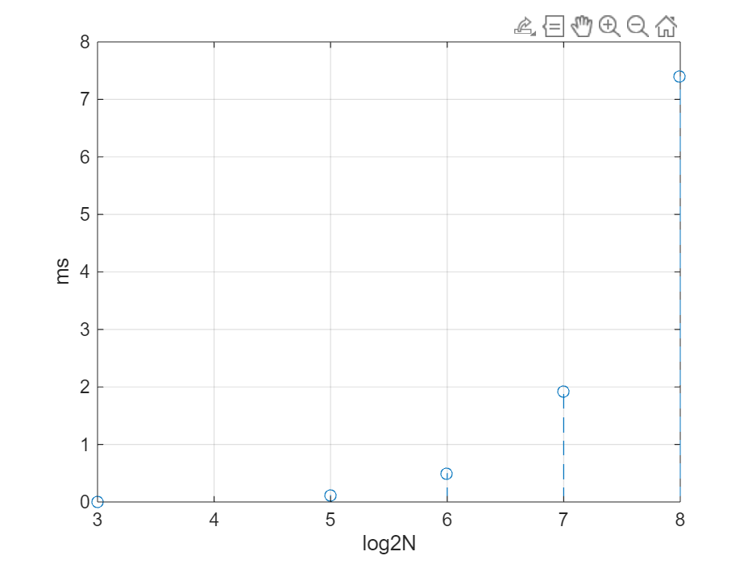

Lab result:
It can be seen from the figure that the calculation time becomes longer after N increases, and it basically satisfies the formula 2*N^2, which is consistent with the analysis in the above question.

3.10 c

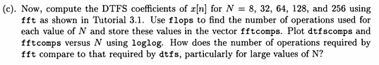

The problem requires to find the fft calculation of Fourier series when N= 8,32,64,128,256, save the results in the fftcomps array; Then the loglog method is used to plot dtfscomps and fftcomps against N on the same graph.
Analysis:
As with b, using the timeit method, write x[n] and calculate. To improve accuracy, each N value is calculated 50 times and averaged in milliseconds.
figure
N0=[8,32,64,128,256];
fftcomps=zeros(1,5);
function [X, x_reconstructed] = dtfs(x, synthesis_flag)
N = length(x);
X = zeros(1, N);
for k = 0:N-1
for n = 0:N-1
X(k+1) = X(k+1) + x(n+1) * exp(-1j * 2 * pi * k * n / N);
end
end
if synthesis_flag
x_reconstructed = zeros(1, N);
for n = 0:N-1
for k = 0:N-1
x_reconstructed(n+1) = x_reconstructed(n+1) + (X(k+1) / N) * exp(1j * 2 * pi * k * n / N);
end
end
else
x_reconstructed = [];
end
end

dtfscomps=zeros(1,5);
for i = 1:length(N0)
N=N0(i);
x = 0.9.^(0:N-1);
t=0;
for j=0:49
f = @()dtfs(x,0);
t_timeit = timeit(f);
t = t+t_timeit;
end
t = t/50;
dtfscomps(i)=t*1000;
end

for i = 1:length(N0)
N=N0(i);
x = 0.9.^(0:N-1);
t=0;
for j=0:49
f = @()fft(x,0);
t_timeit = timeit(f);
t = t+t_timeit;
end
t = t/50;
fftcomps(i)=t;
end
fftcomps = fftcomps.*(1000);
loglog(N0,dtfscomps,N0,fftcomps)
grid on
xlabel('N')
ylabel('t')
legend('dtfs','fft');

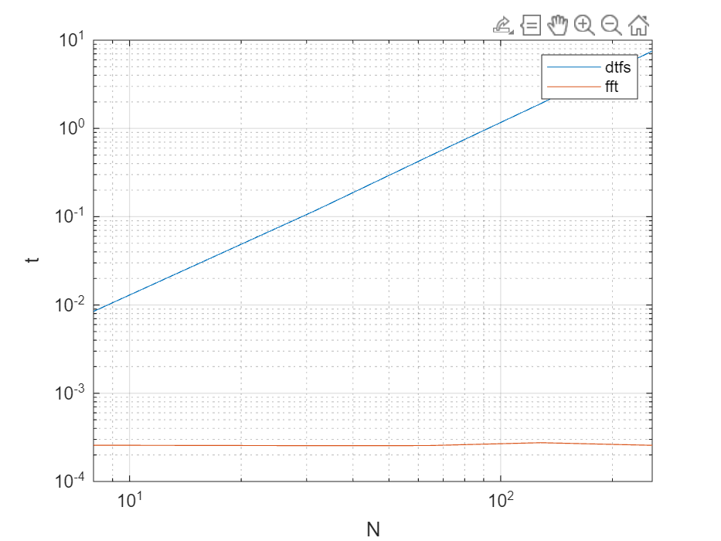
Lab result:
Figure is drawn. As can be seen from the figure, after using the fast Fourier transform, the computation amount N is greatly reduced, and with the increase of N, the computation amount using the custom method increases greatly, while the computation amount using the fft method hardly increases.

3.10 d
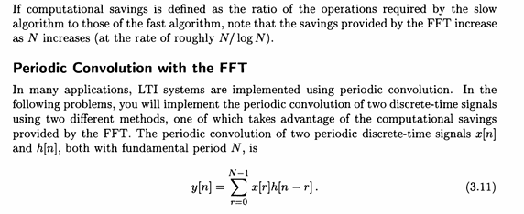

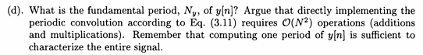

Both h[n] and x[n] functions are known to be signals of period N. The period and computation amount of the periodic convolution function are required.
Analysis:
Since y[n+N] =x[r]*h[n +N]=x[r]*h[n]=y[n] therefore y[n] is a signal of period N, computing an item in the convolution requires n-1 addition and n-multiplication, so the amount of computation after computing one period is N* (n-1)+N*N = 2N^2-N. It corresponds to the computation of O (N^2).

This question needs no code.

Lab result:
y[n] is a signal with period N, and the total number of operations is 2N^2-N

3.10 e

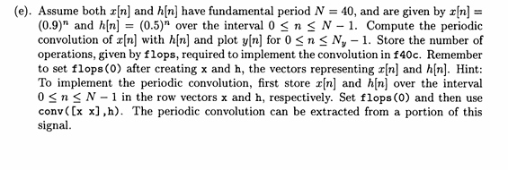

The problem asks to calculate the result of the periodic convolution of two functions x[n]=0.9^n and h[n] =0.5^n when N=40, and record the running time.
Analysis:
Just write the code as required. Since use timeit instead of flops, we use time to replace the number of operations.

clc;
clear;
figure
xn4 = 0:39;
xn = 0.9.^xn4;
hn = 0.5.^xn4;
zn = conv([xn xn],hn);
time = 0;
for i = 0:1:49
f = @()(conv([xn xn],hn));
t_timeie2 = timeit(f);
time = time+t_timeie2;
end
yn=zn(41:80);
stem(xn4,yn,'filled');
grid on
xlabel('n');
ylabel('y[n]')
legend('y[n]')
fprintf('执行时间（秒）： %.6f\n', time/50);
f40c = time/50

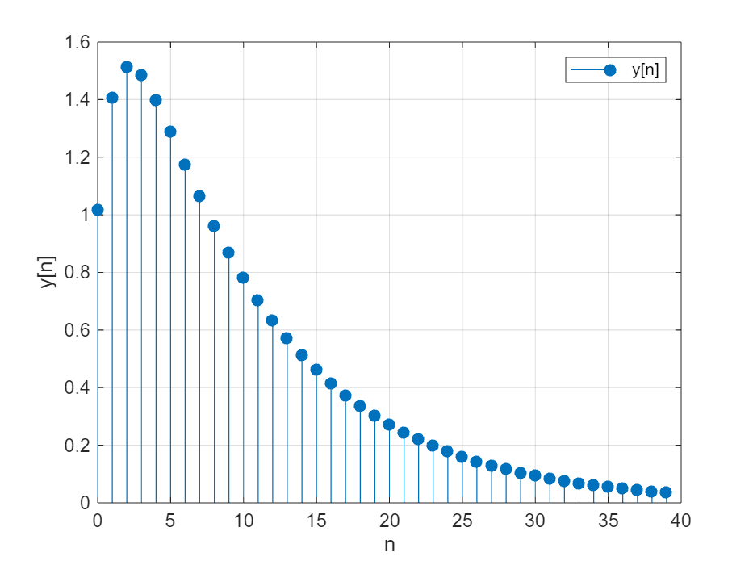
执行时间（秒）： 0.000001
f40c = 1.4519e-06

lab result：
figure is drawn.

3.10 f

They want the same thing as e, but instead of the period being N=80
Analysis:
Same as e.

figure
xn4 = 0:79;
xn = 0.9.^xn4;
hn = 0.5.^xn4;
zn = conv([xn xn],hn);
time2 = 0;
for i = 0:1:49
f = @()(conv([xn xn],hn));
t_timeie2 = timeit(f);
time2 = time2+t_timeie2;
end
yn=zn(81:160);
stem(xn4,yn,'filled');
grid on
xlabel('n');
ylabel('y[n]')
legend('y[n]')
fprintf('执行时间（秒）： %.6f\n', time2/50);
f80c = time2/50

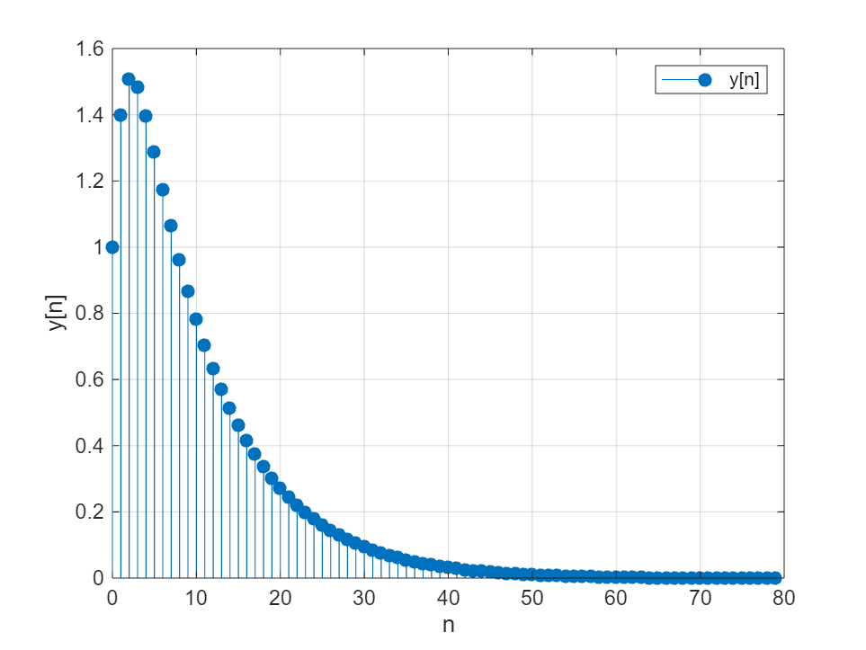
执行时间（秒）： 0.000002
f80c = 2.0495e-06

lab result:
figure is drawn.

3.10 g
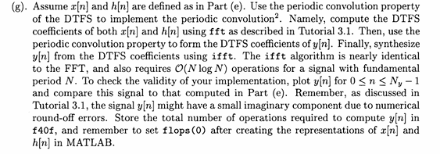

It is required to calculate h[n] and x[n] using FFT to calculate the DTFS of both, and then calculate the DTFS of y[n] through the convolution coefficient of DTFS, and then restore y[n] through the inverse transformation iff, draw a graph and compare with e, and store the calculation time.
Analysis:
Just follow the instructions of the question.

N = 40;
n = 0:N-1;
x = (0.9).^n;
h = (0.5).^n;
tic;
X = fft(x);
H = fft(h);
Y = X .* H;
y = ifft(Y);
time_elapsed1 = toc;
num_ops = 2 * N * log2(N);
fprintf('总操作数: %d\n', num_ops);
fprintf('执行时间 (秒): %.6f\n', time_elapsed1);
figure;
subplot(3,1,1);
stem(n, x, 'filled');
title('周期信号 x[n]');
xlabel('n');
ylabel('x[n]');
subplot(3,1,2);
stem(n, h, 'filled');
title('周期信号 h[n]');
xlabel('n');
ylabel('h[n]');
subplot(3,1,3);
stem(n, real(y), 'filled');
title('周期卷积 y[n]');
xlabel('n');
ylabel('y[n]');
f40f = time_elapsed1

总操作数: 4.257542e+02
执行时间 (秒): 0.004835

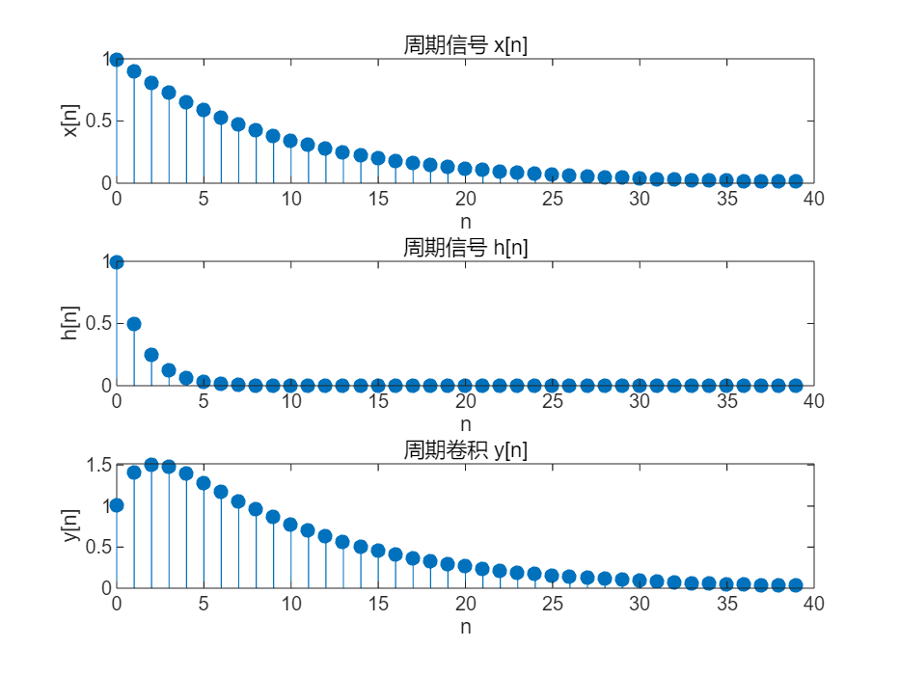
f40f = 0.0048
lab result:
As shown in the figure, the image and time are shown above, and the image is almost the same as the e question

3.10 h
The problem requires the calculation of h[n] and x[n]. When N=80, the DTFS of both are calculated using FFT, and then the DTFS of y[n] is calculated through the convolution coefficient of DTFS, and y[n] is restored through inverse transformation, and the calculation time is stored.
Analysis:
Just follow the instructions of the question
N = 80;
n = 0:N-1;
x = (0.9).^n;
h = (0.5).^n;
f_lops = 0;
tic;
X = fft(x);
H = fft(h);
Y = X .* H;
y = ifft(Y);
time_elapsed2 = toc;
num_ops = 2 * N * log2(N);
fprintf('总操作数: %d\n', num_ops);
fprintf('执行时间 (秒): %.6f\n', time_elapsed2);
f_80f = num_ops;
figure;
subplot(3,1,1);
stem(n, x, 'filled');
title('周期信号 x[n]');
xlabel('n');
ylabel('x[n]');
subplot(3,1,2);
stem(n, h, 'filled');
title('周期信号 h[n]');
xlabel('n');
ylabel('h[n]');
subplot(3,1,3);
stem(n, real(y), 'filled');
title('周期卷积 y[n]');
xlabel('n');
ylabel('y[n]');
f80f = time_elapsed2

总操作数: 1.011508e+03
执行时间 (秒): 0.004218
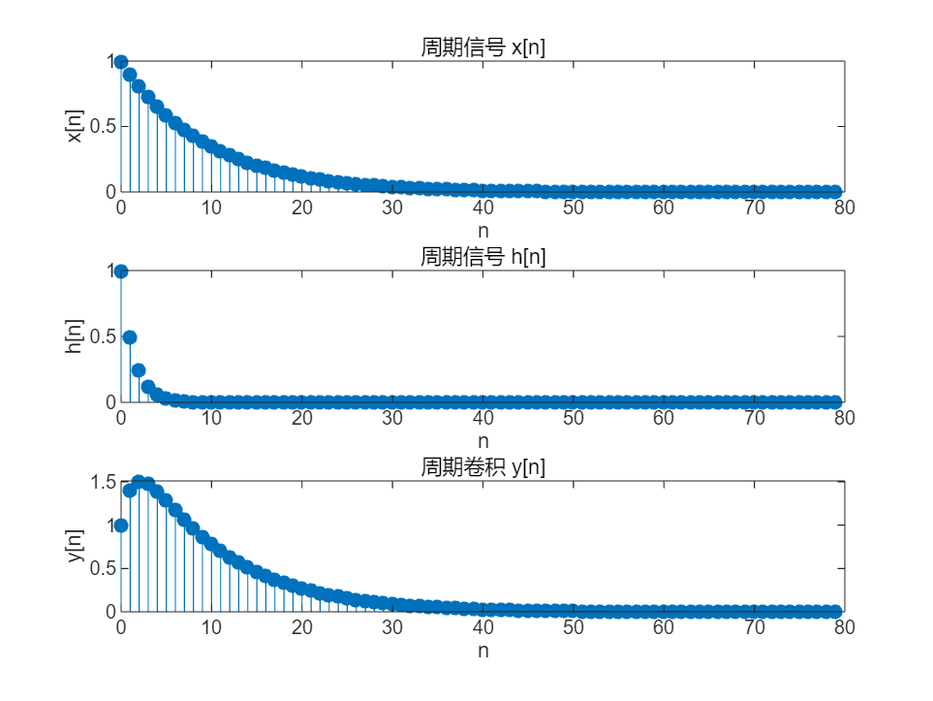
f80f = 0.0042

lab result:
figure is drawn.
3.10 i
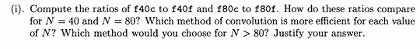

They want to compute f40c/f40f and f80c/f80f, and figure out which algorithm is more efficient for N=40 or N=80. And predict which algorithm is better when N>80.
Analysis:
Just compare.
fprintf('For N = %d:\n', 40);
fprintf(' Direct convolution operations: %f\n', f40c);
fprintf(' FFT convolution operations: %f\n', f40f);
fprintf(' Ratio (f_conv / f_fft): %f\n', f40c / f40f);
if(f40c/f40f <1)
fprintf('conv is better');
else
fprintf('fft is better');
end
fprintf('\n');
fprintf('For N = %d:\n', 80);
fprintf(' Direct convolution operations: %f\n', f80c);
fprintf(' FFT convolution operations: %f\n', f80f);
fprintf(' Ratio (f_conv / f_fft): %f\n', f80c / f80f);
if(f40c/f40f <1)
fprintf('conv is better');
else
fprintf('fft is better');
end
fprintf('\n');

For N = 40:
Direct convolution operations: 0.000001
FFT convolution operations: 0.011878
Ratio (f_conv / f_fft): 0.000107
conv is better
For N = 80:
Direct convolution operations: 0.000002
FFT convolution operations: 0.004218
Ratio (f_conv / f_fft): 0.000470
conv is better
lab result:
Both values are much less than 1, so it is better to convolve the original signal directly. So when N>80, it is better to use convolution.

Note: Please indicate meaning of the symbols in all expressions. Please indicate the coordinate and unit in all figures.
Experience
- Use graphical methods to deepen understanding. MATLAB offers powerful plotting capabilities that help visualize spectral analysis and understand the transition between time and frequency domains. We use Utilize visualization tools to grasp theoretical concepts better, allowing us to see the practical effects of mathematical formulas.
- Use built-in MATLAB functions such as freqz to analyze the frequency response of LTI systems. Experiment by altering parameters and observe their impact on results to understand system characteristics. We use continuously experiment with different settings, leveraging MATLAB's computational power to find patterns.
- Learn the basic theory of filters, refer to filter design cases in the MATLAB community, and practice. MATLAB's fdatool is a very useful auxiliary tool for filter design. When we designing filters, first clarify the design objectives and constraints, then gradually implement the design by learning the steps involved.
Score | 100/100

字体：英文Times new Roman；

